**Team: Test Plan**

**Unit Testing- John**

John has already worked on most of the unit tests for the website.

These are some of the unit tests that john has been working on.

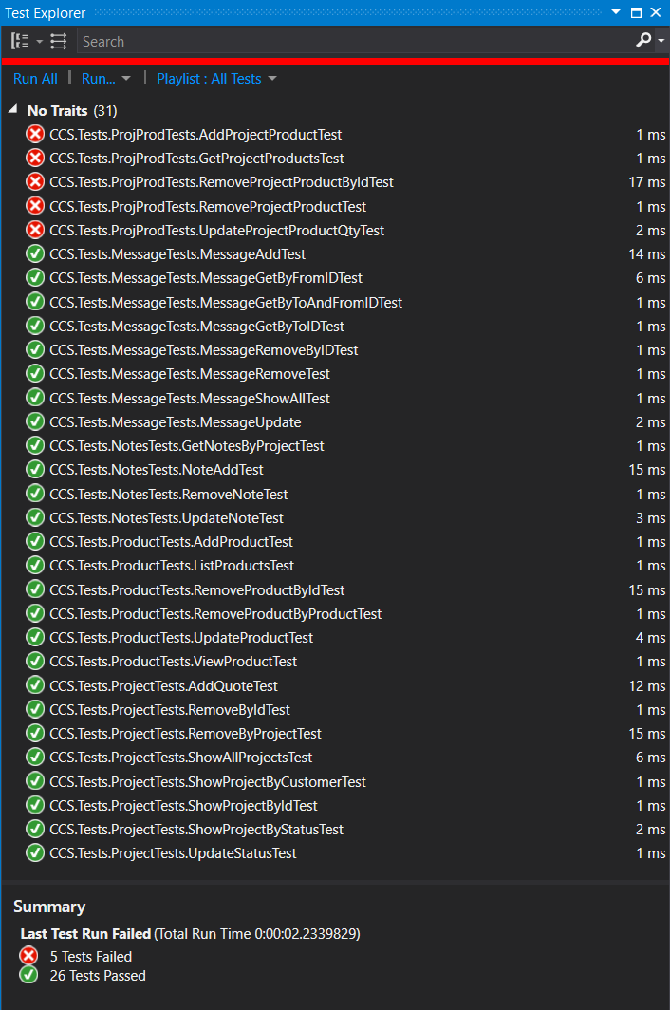

For testing all of the tests need to pass. Some of the tests are not currently passing.

**UI Testing - Cody and Yadira**

Cody and yadira will test the website functionality.

Some of the functionality the site will have.

* Webpage should be responsive and resize correctly on different devices.
* Users should be able to register for an account and log into their account.
* Users should be able to send a message and the message will be stored in the database.
* The pages will be tested for loading speed to make sure that the webpages are not loading slowly. Currently the website views are loading slower than the static html pages.
* Website theme should remain consistent throughout the site.

Our white box testing will be the unit tests that john is writing and the black box testing is the ui testing that is going to be done by yadira and cody.